Creating a simple Editable Feature service:
Using an ArcGIS Online for Organizations subscription, anyone with a “Publisher” account (not a first-level “User” account) can create and publish Editable Feature Service (EFS). Editable Feature Services can be simple or complex, allowing for the use of “controlled” data inputs or allowing for free text assigned to each field. An EFS can allow attached photos to be uploaded and shared and security can be set to allow group, organization, or everyone to view or contribute data. Data contributors can be allowed to add to, edit, delete, or any combination therein.
Establishing a Simple EFS based on a CSV
- Create a CSV file using Microsoft Excel or Google Drive Spreadsheet.

- The fieldnames of the spreadsheet are in the first row.
For example:
Latitude | Longitude | Tree Type | Diameter | Est Tree Height | Bark Condition

- Do not bother putting data in the spreadsheet. You will do this from the map, later. Save the spreadsheet column names by:
  - Excel: “File” -> “Save As” -> [Save as Type] -> “CSV (MS DOS)”
  - Google Drive: “File” -> “Download As” -> “Comma Separated Value”

- Optional way to check your work: Find the CSV file you just saved and open it in Notepad (Windows) or TextEdit (Macintosh) by right clicking the file name and selecting “Open With”. Here is what the file will look like.

Latitude,Longitude,Tree_Type,Diameter,Est_Tree_Height,Bark_Condition

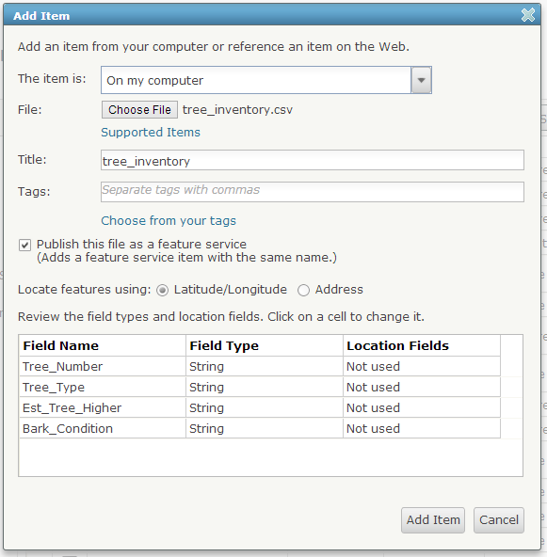
- Open a browser and login to your school or club’s ArcGIS Online for Organizations subscription. Remember, your account must have at least “Publisher” permissions.

- Click “My Content” in the top navigation.

- Press, “Add Item” and “Choose File”.

- Enter a title, tags, and locate features using Latitude/Longitude.

- Be sure to check “Publish this file as a feature service….”

- Press “Add Item”

- The details of your new feature service will be displayed.

- Under the “Layers” section of the page, click the small arrow to the right of the layer name and select “Enable Attachments”. This allows photos to be uploaded when contributing data, especially using mobile applications like “ArcGIS” or “Collector”.
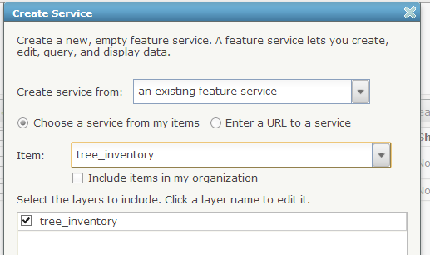
Note: You do not need to press the Publish button. This function creates a tiled map service of your data. Consider using this option only if your data set becomes very large.

- Turn the feature service into an editable feature service (EFS):
  - From the “My Content” page, press the “Create Service” button.
  - Select the new feature service you just created and press “Next”.
  - Press “Next” through geographic extent.
  - Fill in the title and tags and press “Done”.

- From your new feature service’s details page (the page has a small thumbnail view of a map in the upper left corner), click “Open” and select “Open in ArcGIS.com map viewer”.

- If everything worked, you will notice a new “Edit” button on the top navigation bar. Press “Edit”. Click on a desired symbol then click the target location on your map.

- Press “Save” and “Share” your map to the group, organization, or everyone.

- Optional: Review the shared map application from this example at http://bit.ly/13jkCUa
