Power of Field Studies:

Smartphones, Google Docs, & ArcGIS Online

Convert your Google Drive Spreadsheets into GPS-enabled field data collection forms for use in student smart phones! The EdGIS GeoForms tool (http://edgis.org/geoforms) is designed to convert a Google Drive Form that you create into a “GPS-enabled” form for use in student smartphones. The EdGIS GeoForms tool adds JavaScript to a Google Drive Form and allows the form to read from the smartphone’s location services. In short, students can add latitude and longitude to a form of data they are submitting from their smartphone with the click of a single button.

Two workflows describe how teachers and learners can use the EdGIS GeoForms tool:
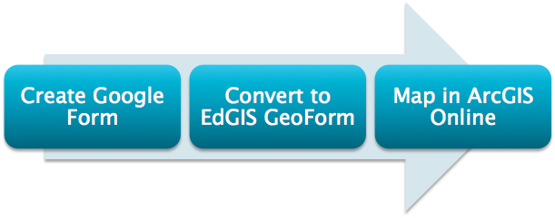

Teacher Workflow: Creating Google Form
- If you don’t already have one, create a Google account by going to google.com and in the upper right click 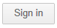 or click
- Once logged in:
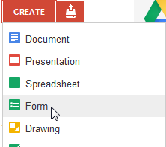
  - Go to http://www.google.com/drive
  - At the top left of the Google Drive page, click the drop down arrow to “Create” a new “Form”.
- Give a label to your questionnaire, then make sure to add these three REQUIRED fields:
  - Latitude type: Text (not required)
  - Longitude type: Text (not required)
  - Accuracy type: Text (not required)

HINT: Use the “Add” button to create new fields. Duplicating questions can corrupt the code used to fill in the form.
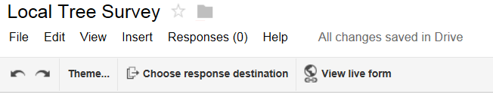
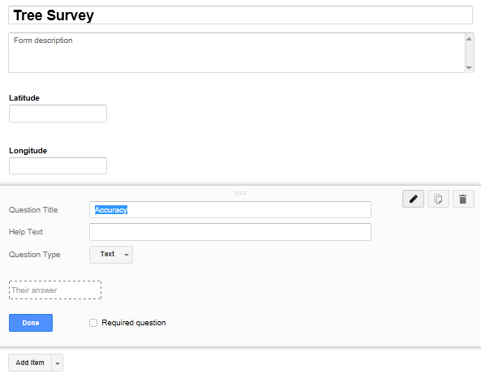

- Add other fields you want collected for the study.
  - Only use the “Add” item button. Don’t copy questions. Rearranging questions can also cause problems. If there are problems opening the form, start again from scratch.
  - If you want to ensure data standardization, i.e. only allowing specific values or keeping uniform spelling, choose check box, multiple choice, or choose from a list.
  - Keep short descriptions for your form. These become the table headers so they should NOT get longer than 20 letters. Frequently, mapping programs will not read longer header rows.
- Choose to view the live form and copy the URL of this form page. (If you are using a Google Apps account from your school, you may need to check a box allowing those outside of your school to see your form.)

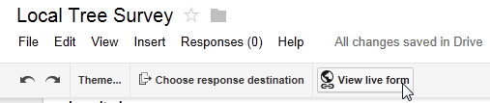

Teacher Workflow: Convert New Form to an EdGIS GeoForm
- Go to http://www.edgis.org and choose the “EdGIS GeoForms for Google Drive Forms”.
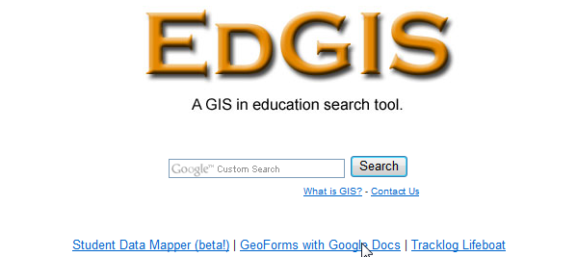

- Paste the “Live View” URL of the Google form you created into the entry box of this page. (This will embed a little button in your Google form that fills in the location and accuracy information from your smart phone is built in GPS.)
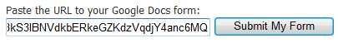

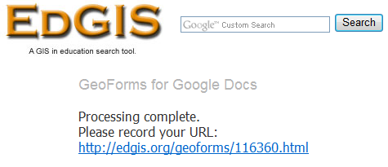
- Copy the new URL and load it in your smartphone’s web browser.

- Any smartphones or tablets pointing to this form can add data independently to your Google Drive spreadsheet.
- Besides the questions you have created to be filled out by your students, there will be a button added at the bottom of the new geoform. When clicked, the button will add the phone’s latitude, longitude, positional accuracy, and time to the form data.
  - IMPORTANT NOTE: To improve the location accuracy of web-based forms:
    - Also, run a “real” or native GPS application or map that tracks your location. This forces your location to update frequently.
    - Have students press the “Get Location Data” button repeatedly.

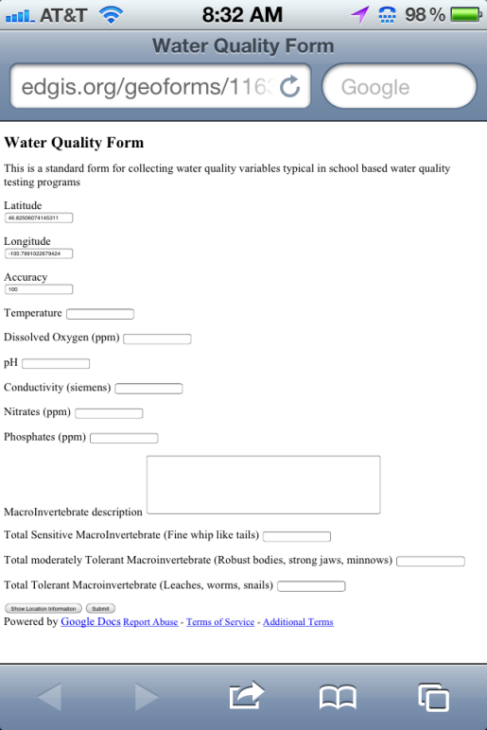

- Once the form is filled out, students can submit one line of data to your spreadsheet by clicking the submit button on the bottom.

Teacher Workflow: Map in ArcGIS Online
- Back in your computer lab, open your form in Google Drive.
- Click File > Share to make your document available to everyone
- Make your spreadsheet accessible for mapping at ArcGIS online, at the top right of the form, click: File > Publish to the web > web based .csv file type.
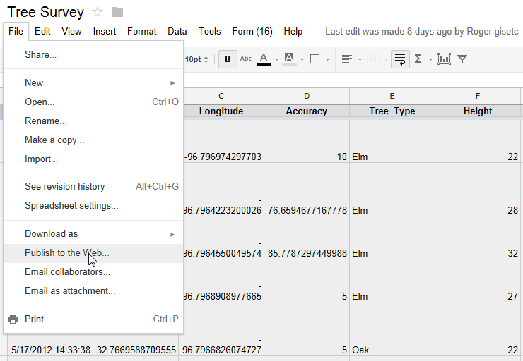

- Save the form as a “Public”, web-based .csv file.
  - Make sure to click “Automatically republish when changes are made”.
  - Copy this new URL. The URL should end in csv. If not, follow the note.

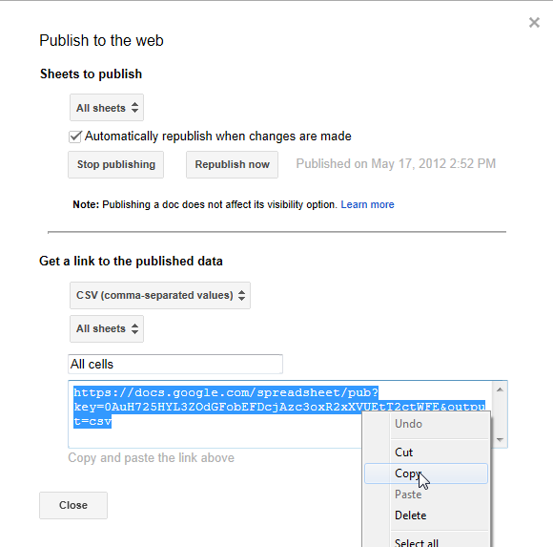
NOTE: Google’s new version of spreadsheets is called sheets. Publishing to csv files are no longer supported but old forms built using google docs should still allow you to publish to csv. Here is how to get sheets to publish to the web as csv:
Copy the “publish to the web” address provided as shown. When you paste this in step 7, change the ending from
/pubhtml to /export?format=csv

- Go to http://arcgis.com and login. If this is your first time, create a login.

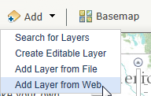
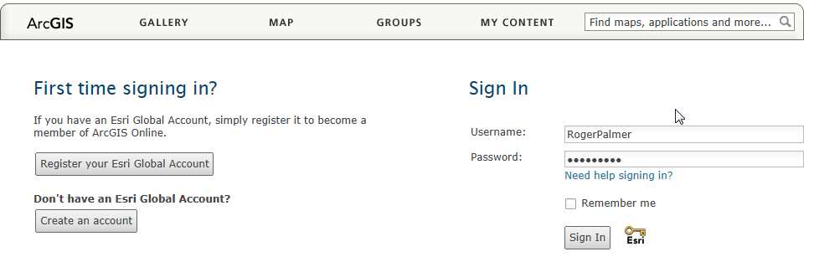
- Click “Map” in the top navigation bar to open a new map.

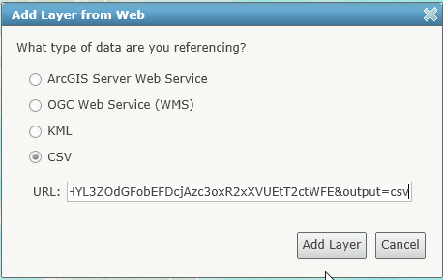
- Click the “Add” button drop down and choose “Add layer from the web”,

- Paste in the URL of your Google form saved as a csv file. (Note, you can only add up to 1000 points of collected data at a time using this method.) If you want more, create more Google forms for each 1000 points.

Sample GeoForms projects are available for viewing or even contributing data. See the EdGIS GeoForms homepage or go directly to sample ArcGIS Online map of the “Student Tree Inventory” at http://bit.ly/XEvFDy. Additional documents and presentation materials for educators are also available at http://edgis.org/geoforms.

- Thematically map your data based on a value you have collected by clicking on the right arrow of your collected data and “Change Symbols”.

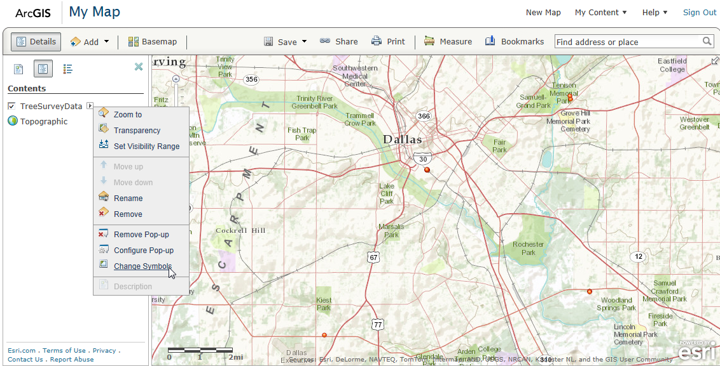
- Choose an appropriate symbol, control the start and end size, then apply your changes.
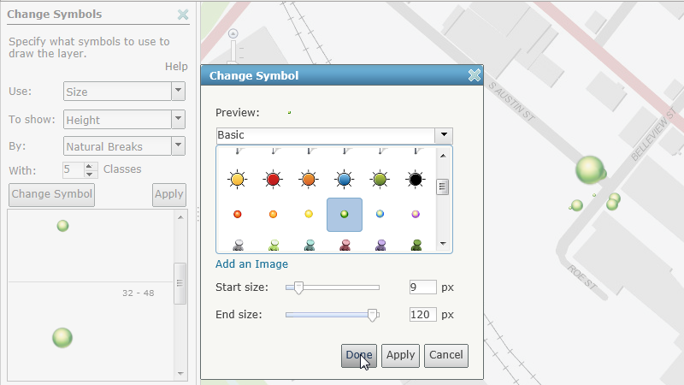

- Save your map 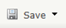 and make sure to add a title and related words that help students discover your maps within your communities or shared groups.

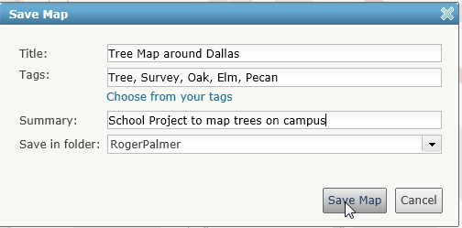
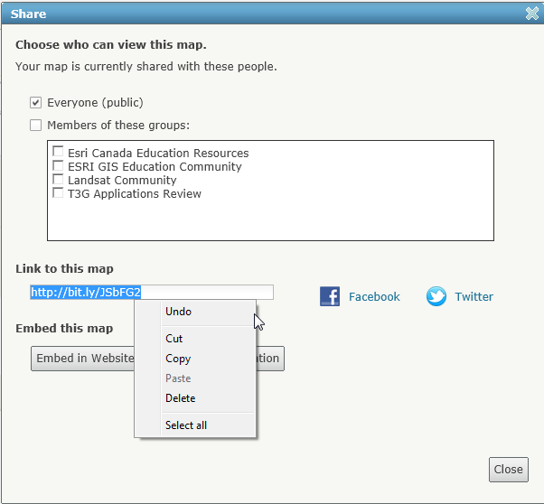
- Click the Share button and copy the URL to email this map link to others or copy the embed code to post this map into a website or in a blog. The map will be automatically updated each time you or your students enter more data to the form.

Basic Student Instruction Sheet
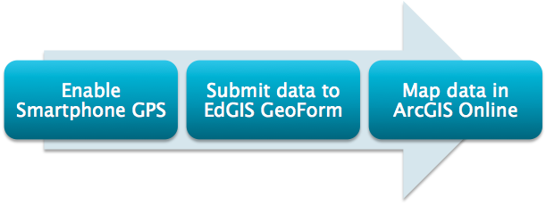
Contribute data to the specified project at ___www.edgis.org/geoforms/ .html___
(The projects unique ####)

- Verify your smartphone location services are turned on. Examples:
  - Apple IOS 6: Settings -> Privacy -> Location Services
  - Apple IOS 4.x: Settings -> Location Services
  - Android: Menu -> Settings -> Location & Security
  - Android 4.1.1: Menu -> Settings -> Personal -> Location Services
- Enter the project URL before going outside. Seeing the screen and typing may be easier inside, where you will be more accessible to students.
- Outside, submit the data requested. After submitting data, use the browser’s back button to return to the data form. Reload the form if you need to submit more than one data point.
- In the computer lab, you will review and analyze the collected data at ArcGIS Online. The web address for reviewing your project’s data is http://www.ArcGIS.com. Use the search box to look for keywords in the project’s description. Terms like “Johnson high tree study” will be helpful to use when creating your project so it will be easier to find at this stage.

